Assignment No: _5__
Date: 05 / 05 / 2026

Title:
(Title based on the application domain and the data structure you will be implementing)

Assignment Type of Submission:
Group: 13  We do the assignment  separately this time. | Yes/No | List all group members’ details:  Student Name: Jiawei Li  Student ID: 25212461 | % Contribution  Assignment Workload  100%



- Problem Domain Description:
This project is about emergency evacuation route planning in a building. During an emergency, occupants may need to move from rooms or corridors to safe exits while avoiding routes that are smoky, crowded, blocked, or close to danger. A simple shortest physical route may not be the safest evacuation route, because a short corridor can still have high risk or congestion. The objective of the system is therefore to find a minimum-cost evacuation path rather than only the route with the fewest corridors.
Graphs are appropriate for this problem because a building can naturally be represented as a network. Rooms, corridors, stairwells, lobbies and exits are vertices. Walkable connections are edges. Each edge stores distance, risk and congestion, which are combined into a single evacuation cost. The implemented system compares BFS, which finds a fewest-edge route, with Dijkstra’s algorithm, which finds the route with the lowest total evacuation cost.

- Theoretical Foundations of the Data Structure(s) utilised
Graph Element | Meaning in this Project
Vertex | Room, corridor, stairwell, lobby or exit
Edge | Walkable connection between two locations
Distance | Length or travel effort of a route segment
Risk | Danger level, such as smoke, heat or proximity to hazard
Congestion | Crowding level or expected delay
Evacuation cost | Combined edge weight used by Dijkstra’s algorithm
A graph G = (V, E) consists of a set of vertices V and a set of edges E connecting pairs of vertices. In this project the graph is undirected because movement is assumed possible in both directions along a corridor unless an edge is removed to simulate a blocked route. The graph is also weighted because each route segment has a cost. An adjacency-list representation is used because it stores only existing edges and is therefore space-efficient for sparse networks such as building layouts.
For each edge, the evacuation cost is calculated as follows:
cost = distance + 2 * risk + congestion
Risk is weighted twice as heavily as distance because, in an evacuation scenario, safety is more important than taking the physically shortest route. This does not force the algorithm to always choose the safest-looking route; instead, it balances distance, risk and congestion into one cost value. Dijkstra’s algorithm then chooses the path with the minimum total accumulated cost.
Algorithm | Purpose in System | Time Complexity | Space Complexity
BFS | Fewest-edge route in an unweighted view of the graph | O(V + E) | O(V)
DFS | Reachability checking between two locations | O(V + E) | O(V)
Dijkstra - linear scan | Weighted shortest path using linear minimum selection | O(V^2 + E) | O(V)
Dijkstra - PriorityQueue | Weighted shortest path using heap-based minimum selection | O((V + E) log V) | O(V + E)
BFS and DFS are linear in the size of the graph because each vertex and edge is processed at most once. Linear-scan Dijkstra is less efficient because each iteration searches all unvisited vertices to find the current smallest distance. The PriorityQueue version improves practical efficiency by making the next-vertex selection heap-based, which is more suitable for large sparse graphs. This is why the PriorityQueue implementation is used as the main weighted routing algorithm.

- Analysis/Design (UML Diagram(s))
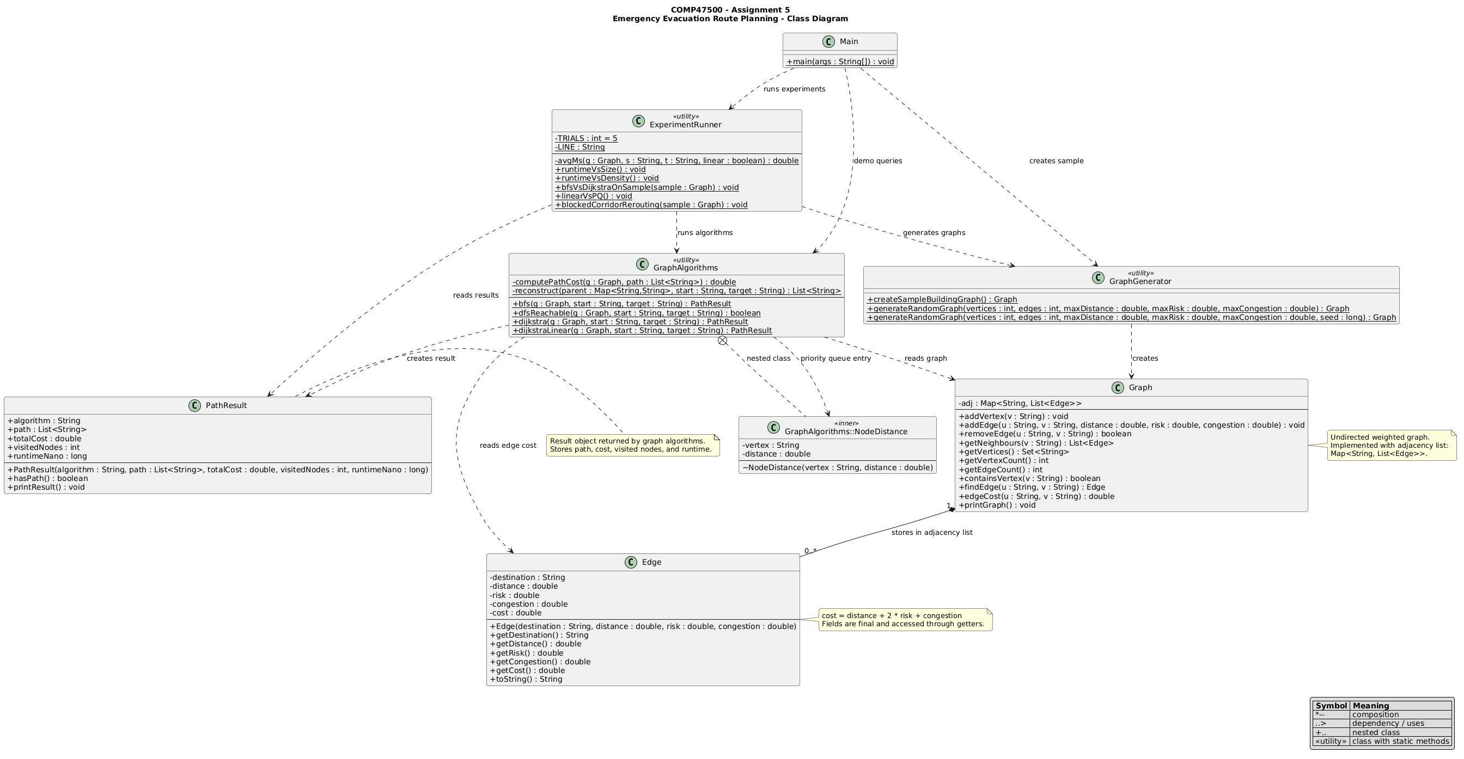
- Code Implementation (please my github account as – https://github.com/jrgarga -- as a collaborator)
GitHub (link):
https://github.com/17Esther/Emergency-Evacuation-Route-Planning
Set of Experiments run and results:
Clearly describe the experimental setup, including input size, number of runs, and performance metrics measured. Present results using tables or figures where appropriate. Interpret and analyse the results rather than only presenting raw data.
File | Purpose
Edge.java | Defines immutable weighted edge objects and the evacuation cost formula.
Graph.java | Implements the custom undirected adjacency-list graph.
PathResult.java | Stores path, cost, visited-node count and runtime.
GraphAlgorithms.java | Implements BFS, DFS, Dijkstra with PriorityQueue and linear Dijkstra.
GraphGenerator.java | Creates sample and random graphs.
ExperimentRunner.java | Runs all experimental tests and prints tables.
Main.java | Demonstrates the system and runs all experiments.
All experiments were run from the Main class using terminal compilation and execution. Runtime was measured with System.nanoTime(). For the main performance experiments, each setting used 1 warm-up run followed by 5 measured trials and the average runtime is reported. Random graphs were generated with fixed seeds to make the results reproducible. The main metrics are runtime in milliseconds, total evacuation cost and, where relevant, speedup.

Experiment 1: BFS vs Dijkstra on the sample building graph
To compare the route chosen by BFS with the route chosen by Dijkstra’s algorithm. BFS ignores weights and returns the route with the fewest corridors. Dijkstra uses the evacuation cost and returns the route with the lowest total weighted cost.

Comments:
Discuss key design decisions, implementation challenges, and any limitations encountered. Reflect briefly on how the solution could be improved.

- Video of the Implementation running
Provide a short video demonstrating the system in execution. The video should briefly explain the main functionality and highlight experimental results. Silent screen recordings are not recommended.

Zoom (link & password):
Comments:

Please save as pdf and submit on Brightspace
Students belonging to the same group please submit the same file .

